Driven Racing Oil™ Injector Defender Diesel Fuel Additive
Huntersville, NC – A new diesel fuel performance additive from Driven Racing Oil™ is designed to clean and protect fuel injectors while improving the performance of diesel engines.
Driven Injector Defender Diesel features a unique detergent that prevents injector deposits by dispersing particles and contaminants in the fuel, allowing them to pass through injectors without clogging. Not only does Injector Defender Diesel provide protection against new deposits, it can also clean up current ones, restore diesel engine performance and improve fuel mileage. In addition, Injector Defender Diesel boosts Cetane, improves low temperature fuel flow, and increases lubricity to reduce injector and fuel pump wear. Injector Defender Diesel is a true all-in-one Diesel performance fuel additive. Each 10-ounce bottle of Injector Defender Diesel treats up to 100 gallons of fuel.
Part Number: #70080 (10 oz. bottle); Price: $9.99
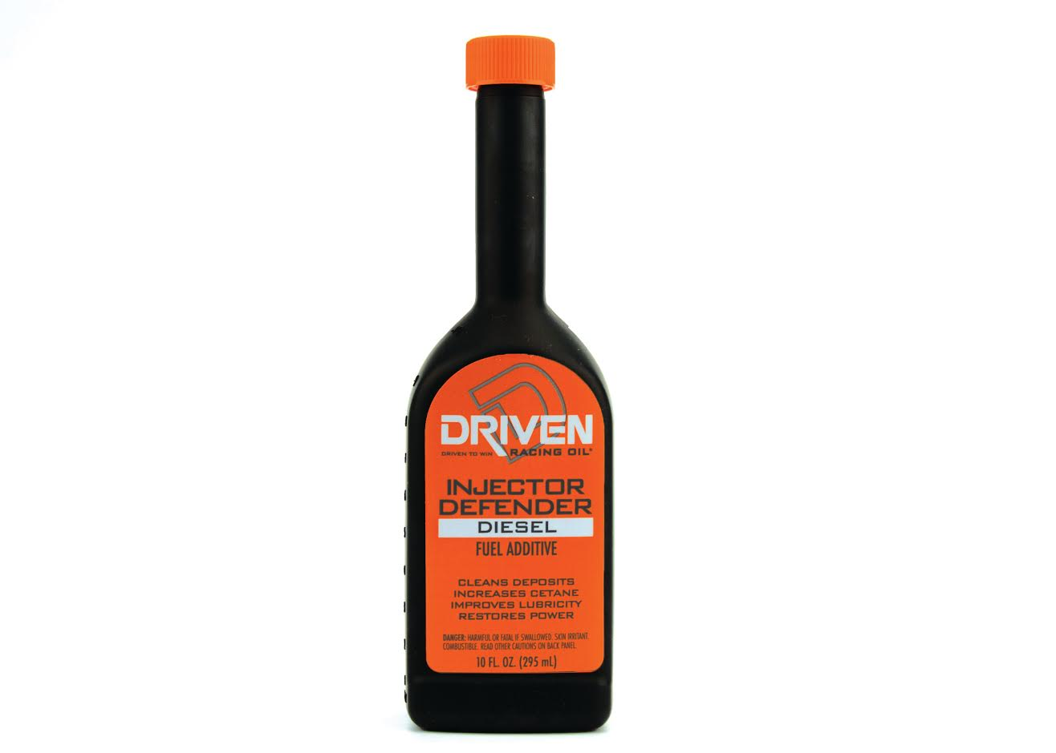
About Driven Racing Oil™
Born from Joe Gibbs Racing, one of the most successful NASCAR teams of the past two decades, Driven Racing Oil™ utilizes cutting-edge lubricant technology and on-track research for maximum performance gains from all of its product offerings. Competition drives innovation, and Joe Gibbs Racing originally developed the Driven brand of oils to advance engine and driveline performance on the racetrack. From full-synthetic race oils to engine break-in oils, Driven offers a wide range of race and street products that deliver performance, protection and value.

